📘 Assignment: Reporting and Recommendations

🔹 Task 1: Review a Vulnerability Report Template
Objective: Download and review a sample vulnerability assessment report template.
Recommended Resource
OWASP Testing Guide & Resources
Main Sections of a Vulnerability Assessment Report
Section | Purpose
Executive Summary | High-level overview of the assessment, major findings, and overall business risk.
Findings | Details of each identified vulnerability, including description, impact, and severity.
Recommendations | Practical remediation steps for developers and administrators.
Appendix | Supporting information such as screenshots, scan results, references, and technical details.

🔹 Task 2: Executive Summary
Scenario: Vulnerability assessment of a fictional food delivery application similar to Zomato.
Executive Summary
A vulnerability assessment was conducted on a fictional food delivery application to evaluate its security posture. The assessment identified several security weaknesses that could potentially expose sensitive customer information and affect the application's availability if left unaddressed. The most significant findings included a possible SQL Injection vulnerability and an Insecure Direct Object Reference (IDOR) issue. Although no evidence of active exploitation was observed during testing, these vulnerabilities present a moderate to high business risk. It is recommended that the identified issues be remediated promptly and that regular security assessments be incorporated into the application's development lifecycle.

🔹 Task 3: Sample Vulnerabilities
Vulnerability 1 – SQL Injection (SQLi)
Risk Rating: 🔴 High
Description:
The application accepts user input without sufficient validation or parameterization. An attacker could attempt to manipulate database queries through specially crafted input, potentially exposing or modifying sensitive information.
Business Impact:
- Unauthorized access to customer records
- Exposure of payment-related information
- Potential compromise of the application database
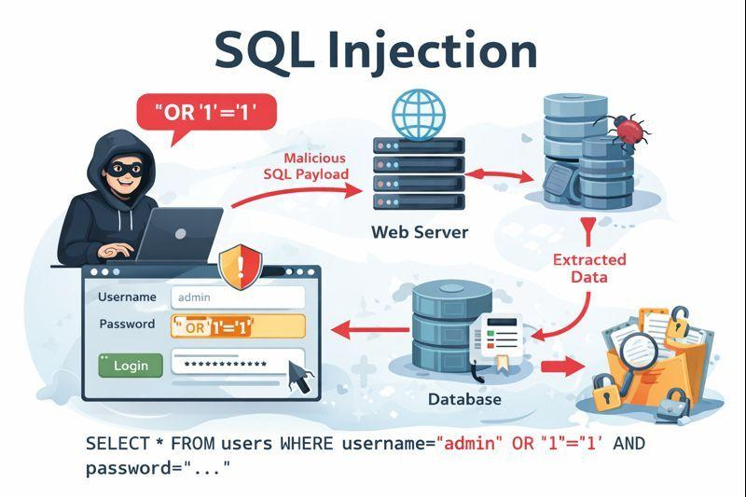
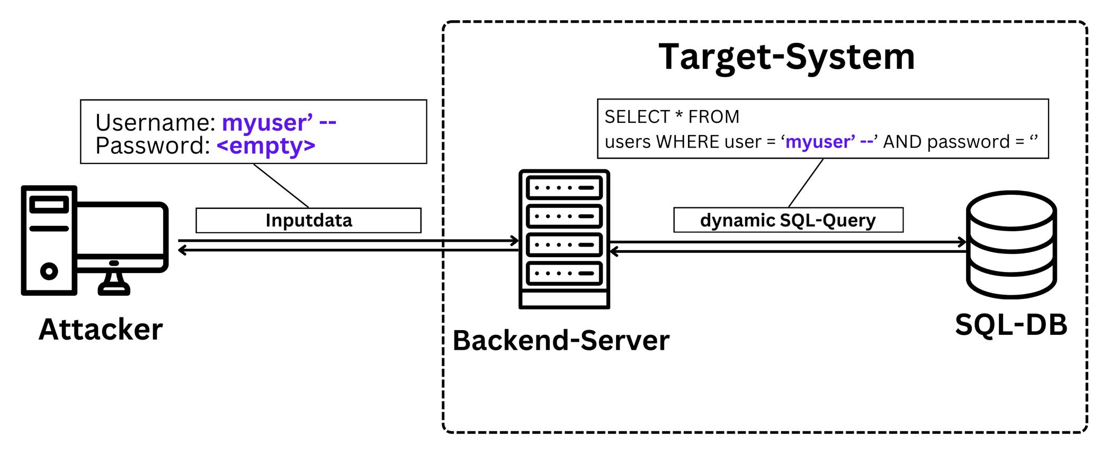
Vulnerability 2 – Insecure Direct Object Reference (IDOR)
Risk Rating: 🟠 Medium
Description:
The application may expose internal object identifiers without verifying whether the requesting user is authorized to access the referenced resource.
Business Impact:
- Unauthorized viewing of another user's information
- Privacy violations
- Possible exposure of order history or account details
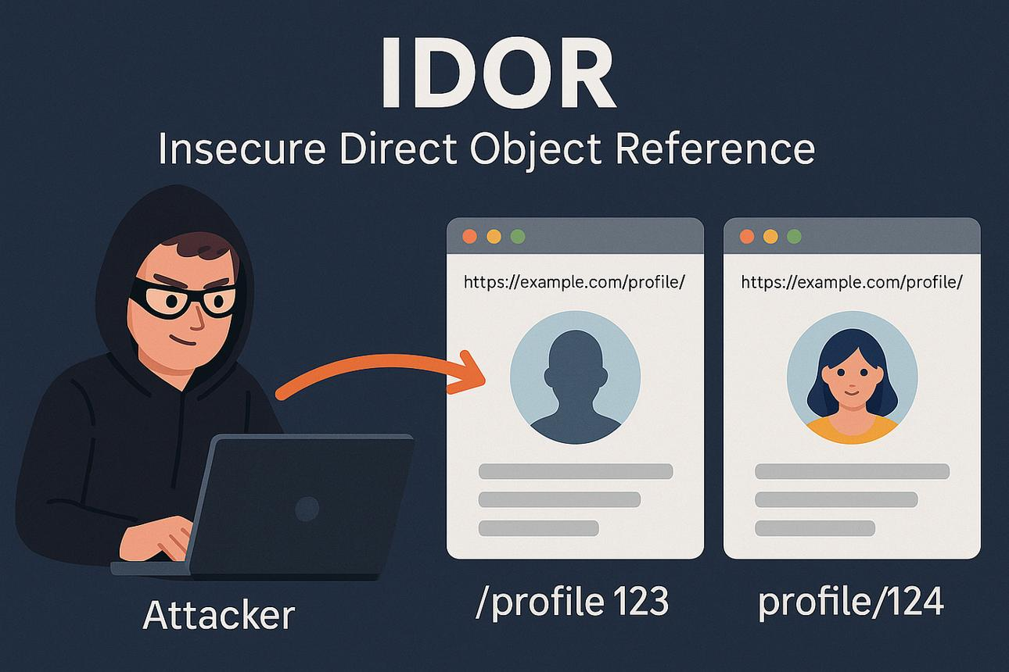
🔹 Task 4: Recommendations
SQL Injection
Recommendation:
- Use parameterized queries (prepared statements).
- Validate and sanitize all user input.
- Apply the principle of least privilege to database accounts.
- Perform regular code reviews and security testing.

Insecure Direct Object Reference (IDOR)
Recommendation:
- Perform server-side authorization checks for every request.
- Verify that users can only access their own resources.
- Avoid exposing predictable object identifiers where possible.
- Implement role-based access control (RBAC).

🔹 Task 5: PDF Report
Executive Summary
A vulnerability assessment was performed on a fictional food delivery application similar to Zomato. The assessment identified a small number of high-risk security weaknesses that could affect customer data confidentiality and application integrity if left unresolved. The most significant findings were a potential SQL Injection vulnerability and an Insecure Direct Object Reference (IDOR) issue. No evidence of active exploitation was observed during the assessment. Prompt remediation is recommended to reduce business risk and improve the application's security posture.
Finding 1: SQL Injection (High)
Description: Unsanitized user input could allow malicious SQL queries to interact with the database. Recommendation: Use parameterized queries (prepared statements), validate input, and apply least-privilege database accounts.

Finding 2: Insecure Direct Object Reference (Medium)
Description: Object identifiers could be manipulated to access resources belonging to other users. Recommendation: Enforce server-side authorization checks for every request and use indirect object references where appropriate.
Conclusion Regular vulnerability scanning, secure coding practices, patch management, and periodic security testing are recommended to reduce future risk.

